Array

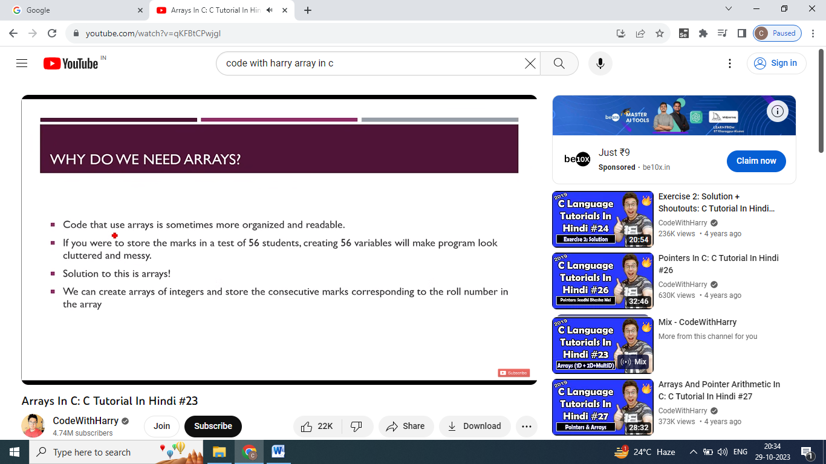

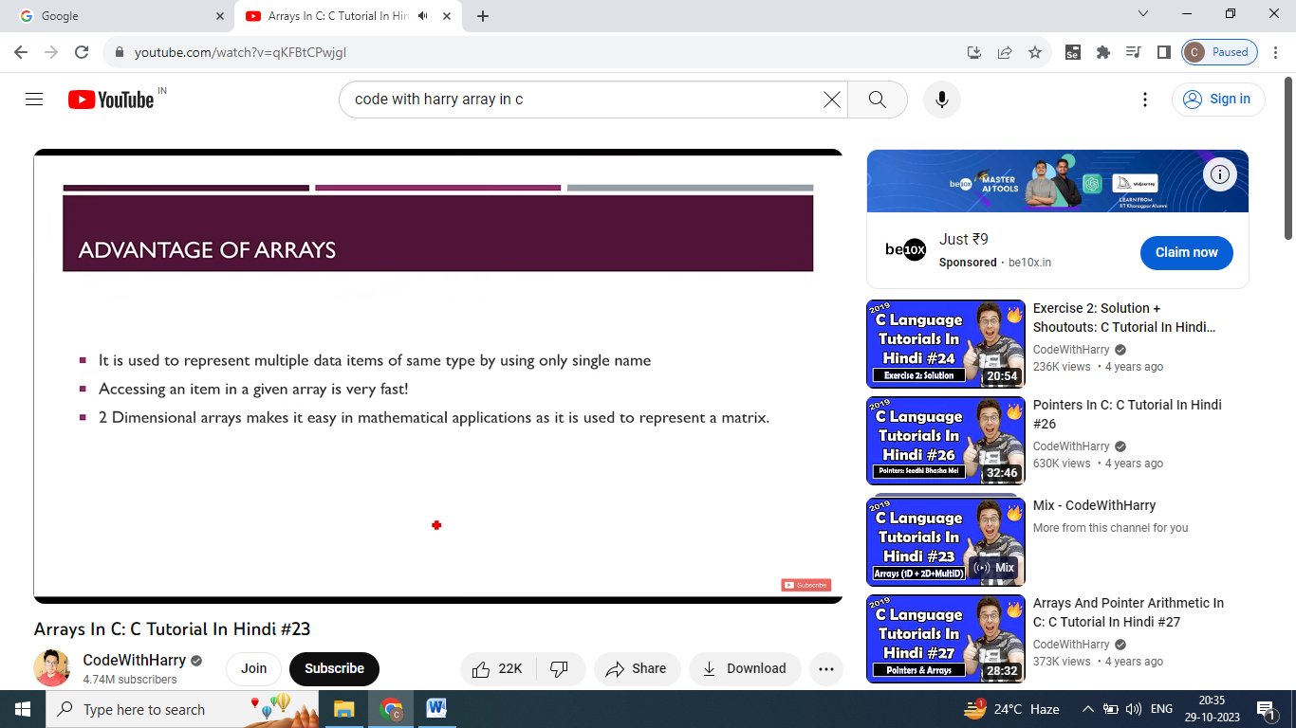

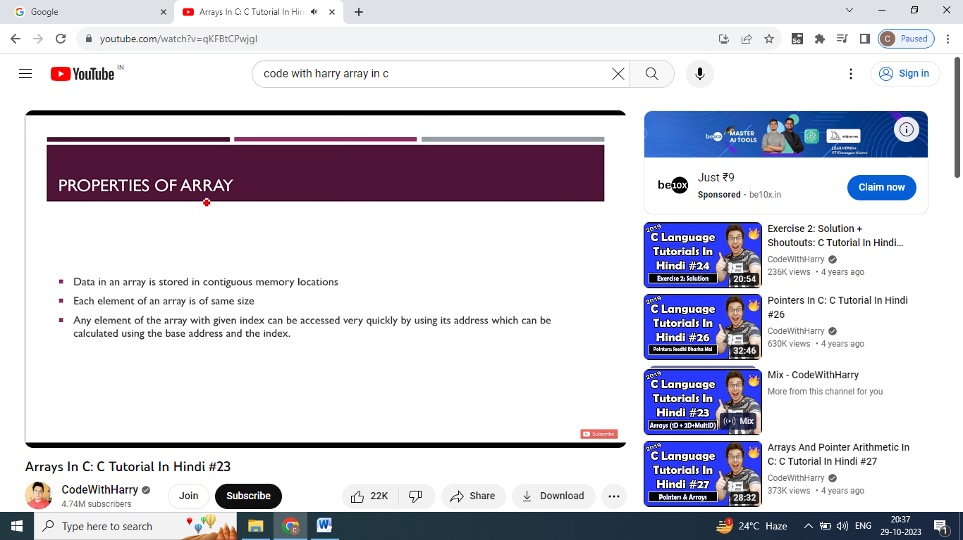

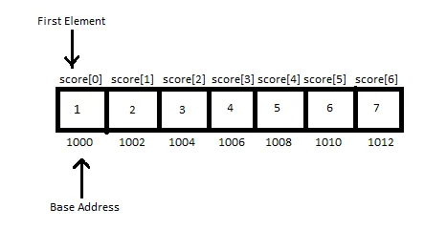

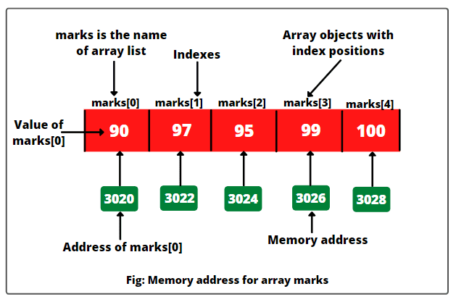

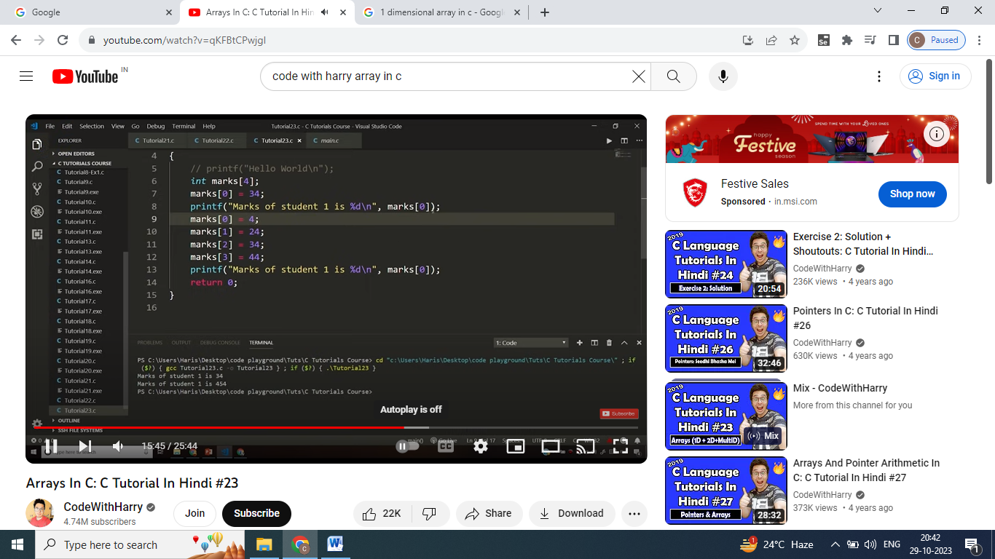

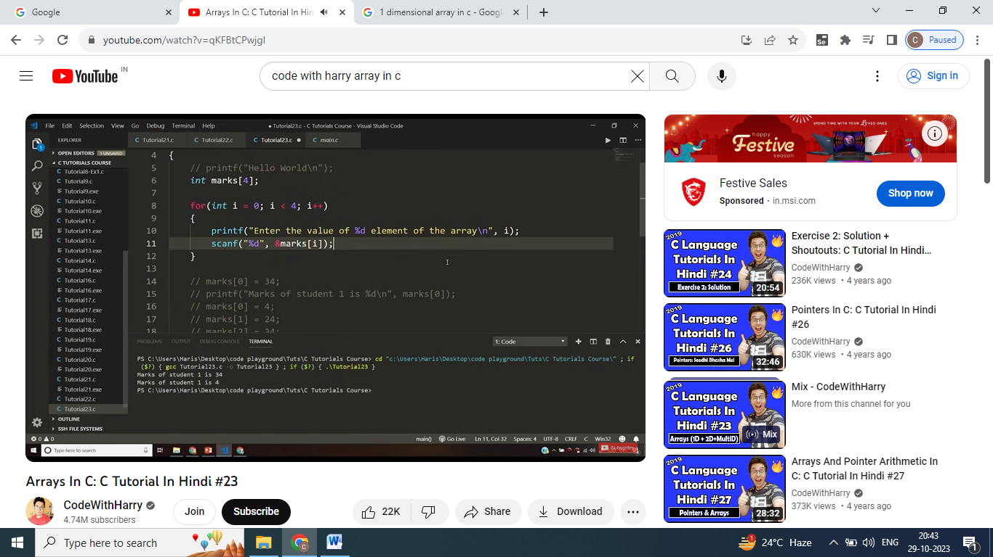

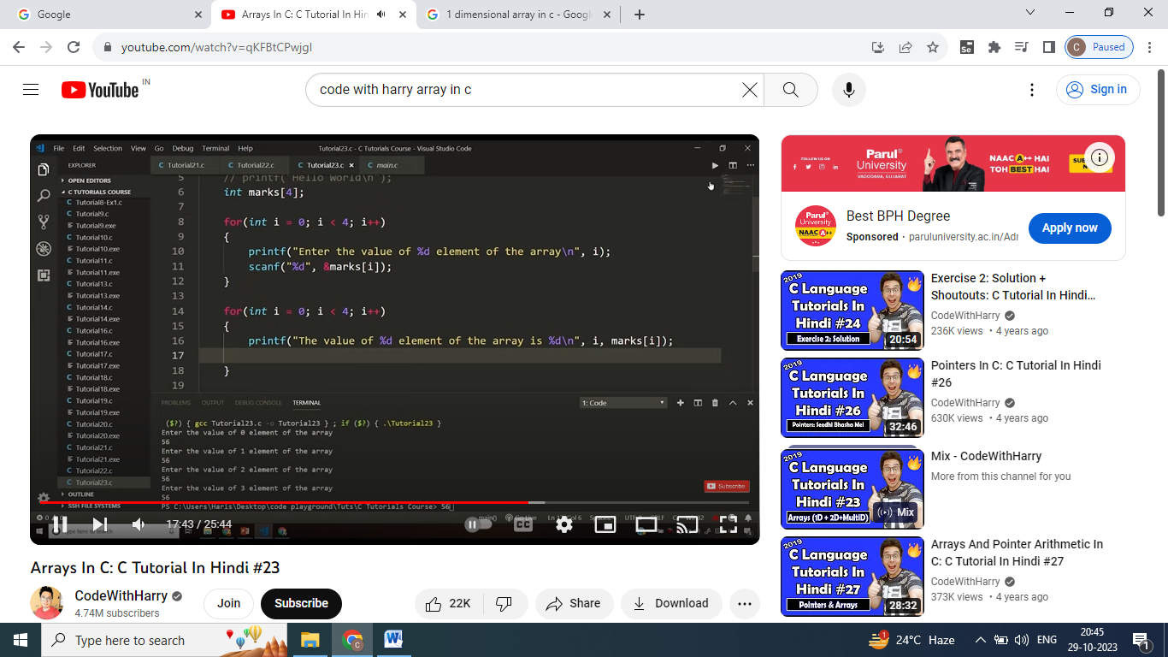

**2-D Array**

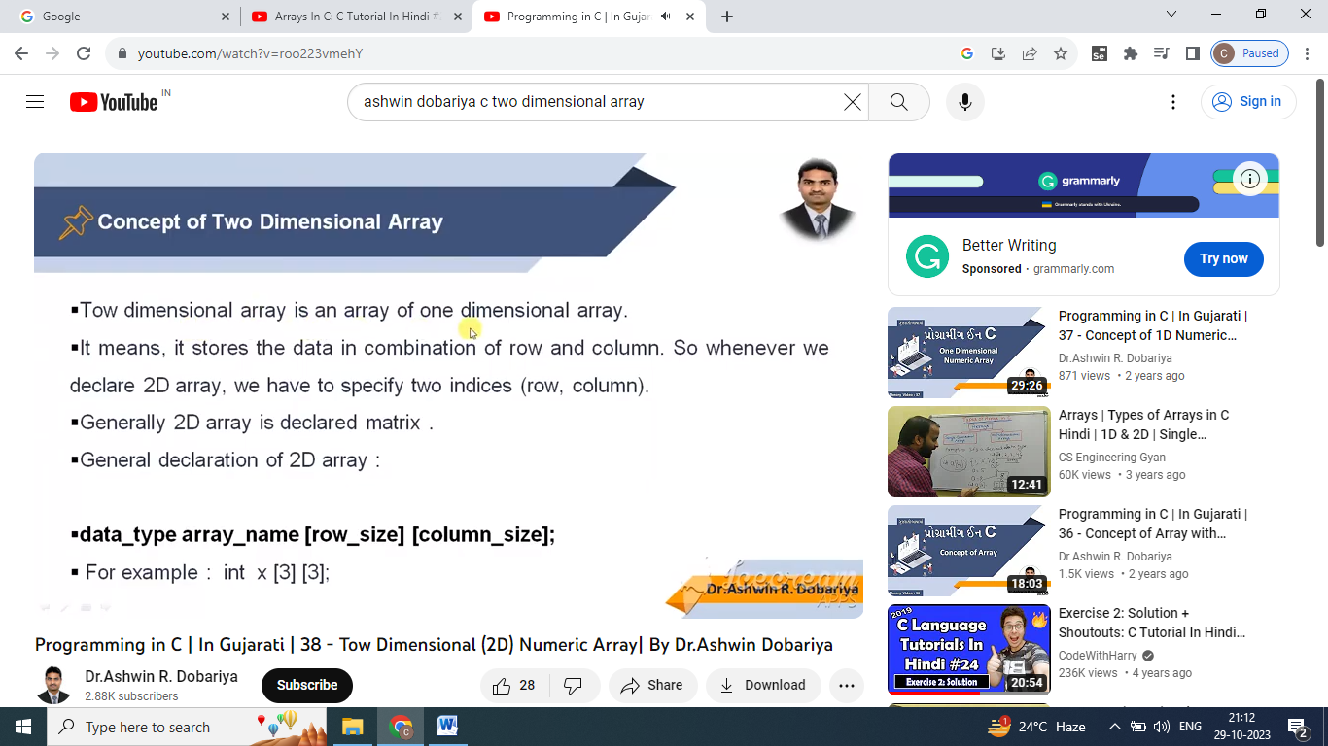

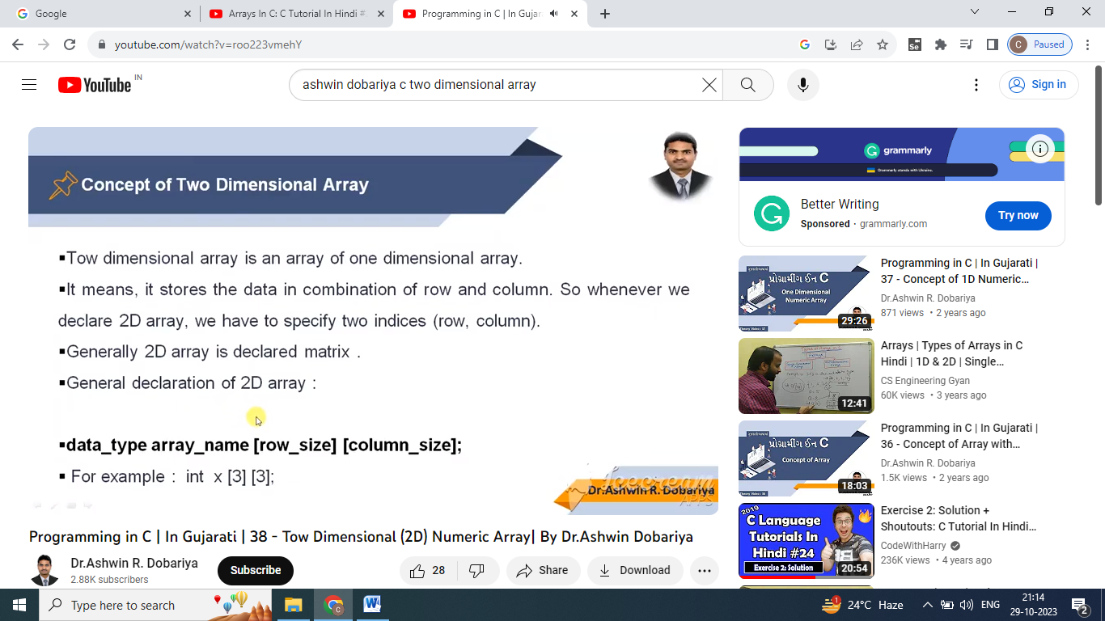

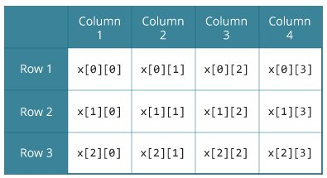

**2-D Array Declaration**

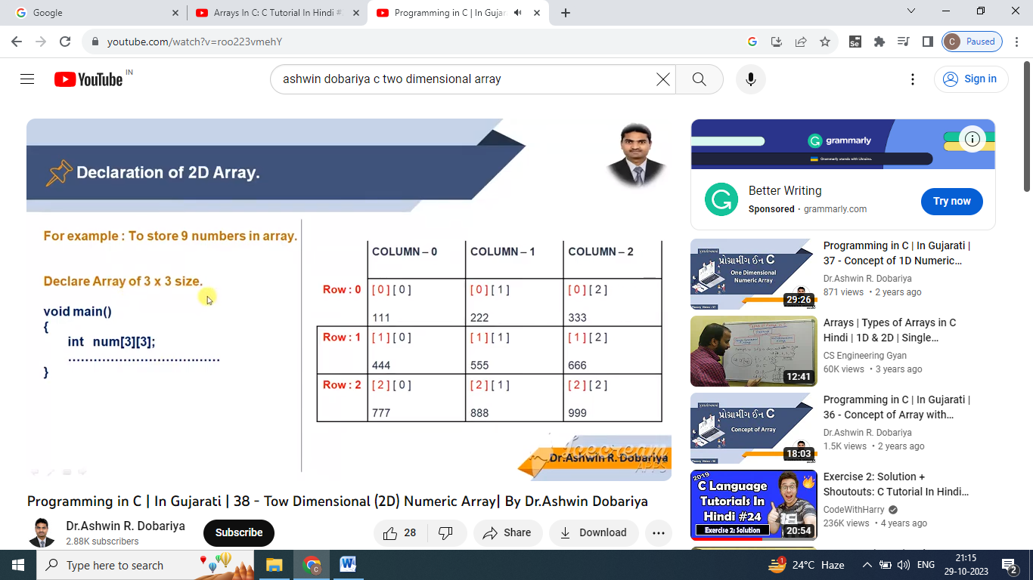

**2-D Array Initialization**

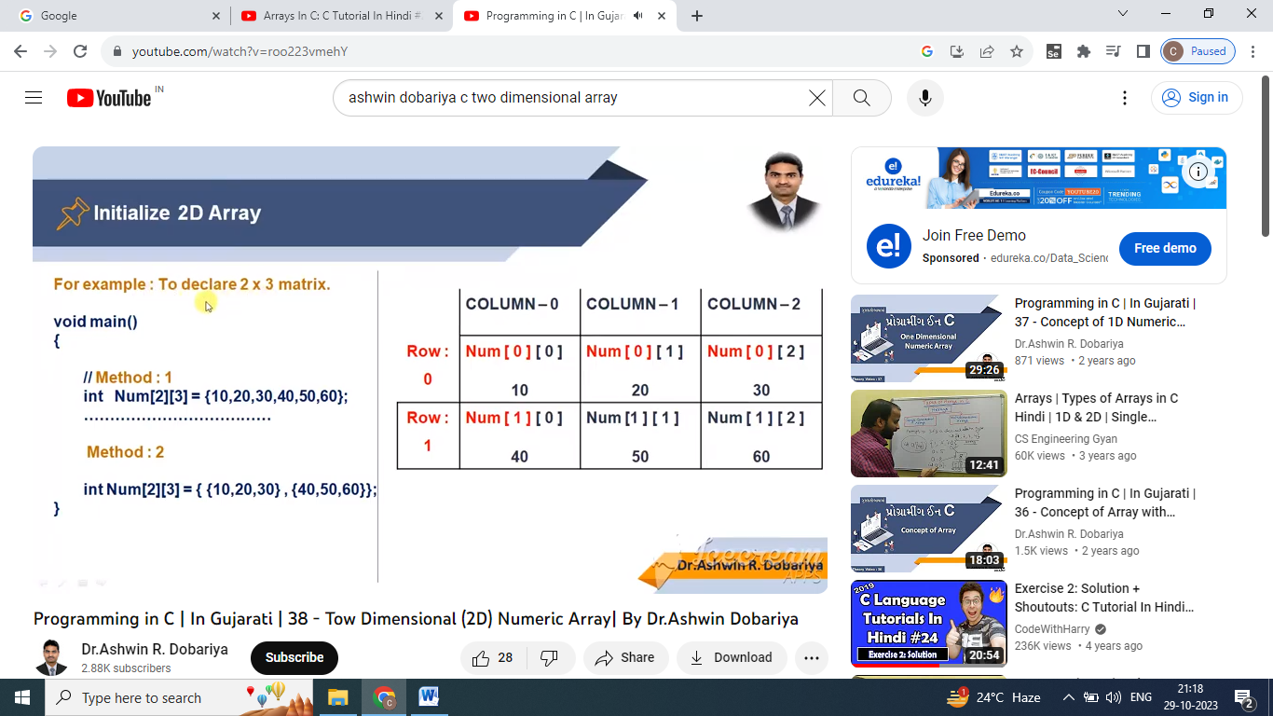

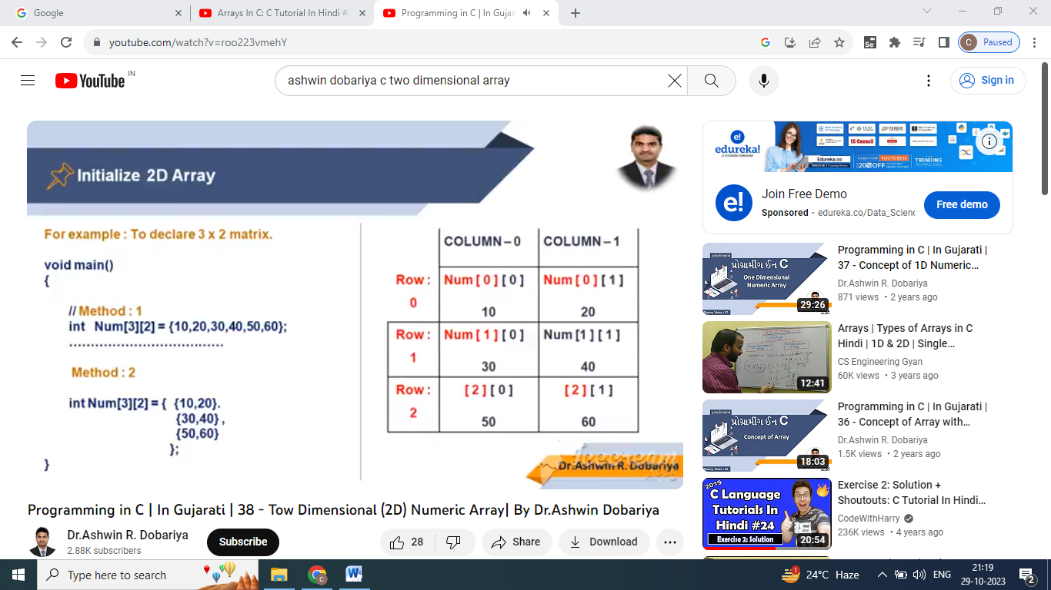

**2-D Array User Input**

|  |  |  |  |  |  |  |  |  |  |  |  |  |  |  |  |  |  |
| --- | --- | --- | --- | --- | --- | --- | --- | --- | --- | --- | --- | --- | --- | --- | --- | --- | --- |
|  | |  |  |  |  | | --- | --- | --- | --- | |  | **COLUMN 0** | **COLUMN 1** | **COLUMN 2** | | **ROW 0** | NUM [ 0 ] [ 0 ]  10 | NUM [ 0 ] [ 1 ]  20 | NUM [ 0 ] [ 2 ]  30 | | **ROW 1** | NUM [ 1 ] [ 0 ]  40 | NUM [ 1 ] [ 1 ]  50 | NUM [ 1 ] [ 2 ]  60 | | **ROW 2** | NUM [ 2 ] [ 0 ]  70 | NUM [ 2 ] [ 1 ]  80 | NUM [ 2 ] [ 2 ]  90 | |

